Worksheet 9.2

Science under scrutiny
Student: Class:
Scientists and their discoveries do not inhabit an isolated world. Some scientific discoveries can be detrimental to different factions within the community. Many of these groups have a great deal of influence over what people think about a scientific issue or even over the funding of the scientific work itself. Read the following two examples of science and society not always being in absolute agreement.

Smokescreen
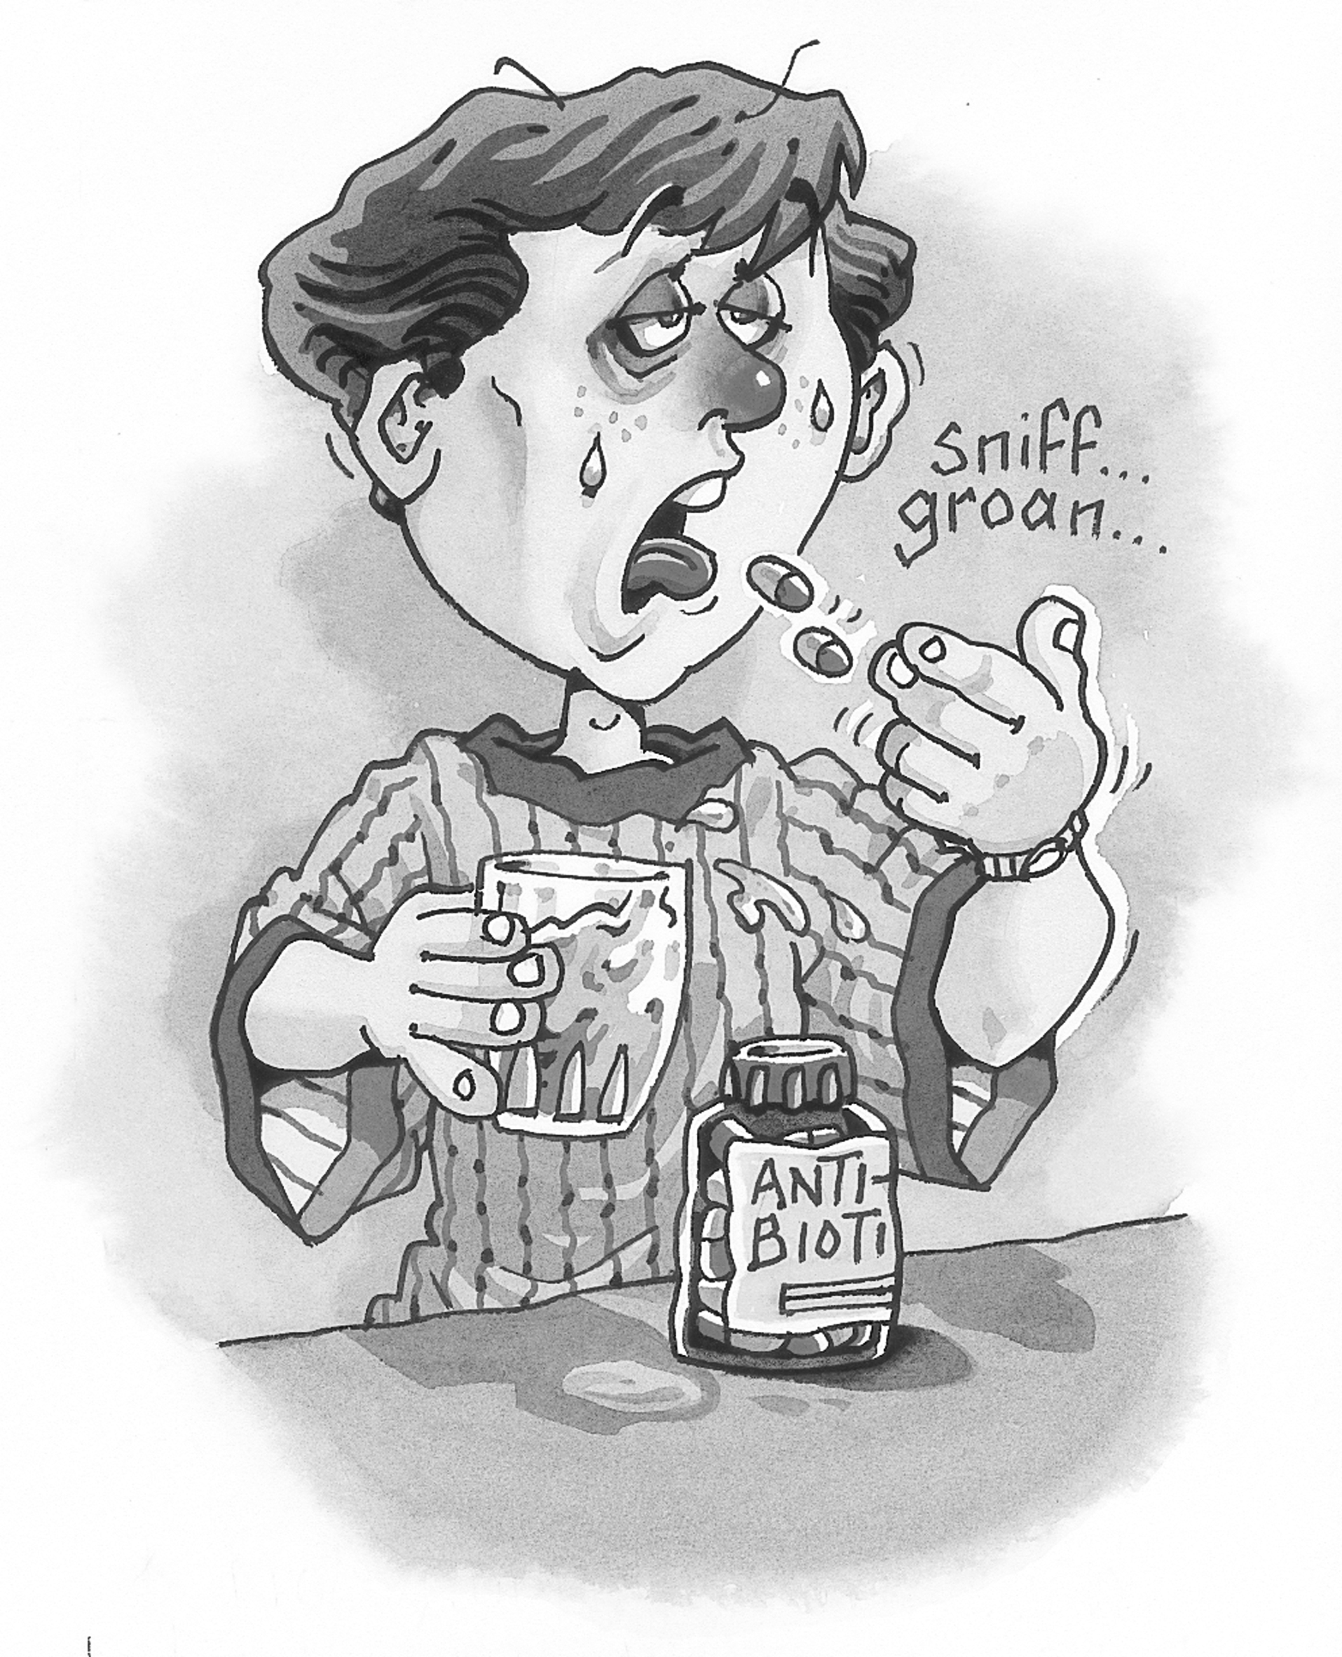
The viewpoint of the tobacco industry — that it needs to make profits to remain in business — is quite different to that of the scientists who discovered the link between tobacco smoking and disease. Early last century, smoking was an acceptable social habit. However, as scientists started to gather evidence of its link with heart disease and lung cancer, people started to examine the value of smoking and to consider the dangers for non-smokers who breathe others’ cigarette smoke.
In 1964, doctors in the United States issued the first official warning about the health hazards of smoking, based on the results of their research. This scientific evidence was extremely damaging to the very large tobacco industry and they opposed it with research of their own.
Some people believe that the tobacco industry should pay the public health bills of those suffering the ill effects of smoking. This debate continues, but society no longer accepts that smokers have the right to smoke in many public places. Laws have been passed that prohibit smoking in all enclosed public areas, including offices and most motel rooms. Tobacco advertising has been banned in the Australian media. Millions of dollars have been spent educating people about the risks of smoking, fighting legal compensation battles and establishing laws.
Despite this, it is only in recent years that some parts of the tobacco industry have admitted the link between tobacco smoking and disease, and that the nicotine in tobacco is addictive.

Pill poppers
Another example is the overuse of antibiotics, the chemicals that are used to kill disease-causing microbes. It is a fact that, although more people were injured in World War II than World War I, fewer died. This was due to the discovery and development of antibiotics between the wars — their availability during World War II saved many lives. Despite the great advantages of antibiotics, we now know that their overuse can cause an increase in the numbers of resistant microbes (that is, microbes that cannot be killed by the antibiotics). The drug companies that market antibiotics want to encourage increased sales of their drugs. Some patients are in the habit of taking medicine for any ailment, and doctors write prescriptions so that they do not appear negligent.
However, overuse of antibiotics can result in people dying from diseases that could have been cured by antibiotics in the past, but for which the drugs have lost their effect. This product of science has amazing benefits to society, yet it can lead to negative effects if not properly used. It is up to us to be responsible and take antibiotics only when they are strictly necessary, so that they can continue to be effective in future.

1. Why was the tobacco industry so reluctant to agree with the scientific findings about the serious effects of smoking on people’s health?

Worksheet 9.2

Page 2

2. Some people have suggested that a law should be made to require doctors to send a patient swab or sample to a pathologist for confirmation of a bacterial infection before prescribing antibiotics for that patient. This way, antibiotics would be used much less often, which would slow down, if not stop, bacteria developing resistant strains. What do you think are the main problems with this idea?

3. Imagine a company, employing thousands of workers, that makes billions of dollars every year from the sale of a product called Fatsoff, a weight-loss product that works on 50 per cent of people. Based on revolutionary scientific research into chemicals called statins, this treatment allows these people to lose weight and keep it off provided that they keep taking the product, which is quite expensive. If they stop taking the product, they put on weight again. In Australia alone, 4 million people use it regularly. From the purchase price, a large slice goes to the government so that it can fund other health areas such as cancer research and subsidise health care for the poor.
Unfortunately, five years after it hit the market, new research uncovered evidence that prolonged use of Fatsoff caused fatal heart attacks in 2 per cent of users.
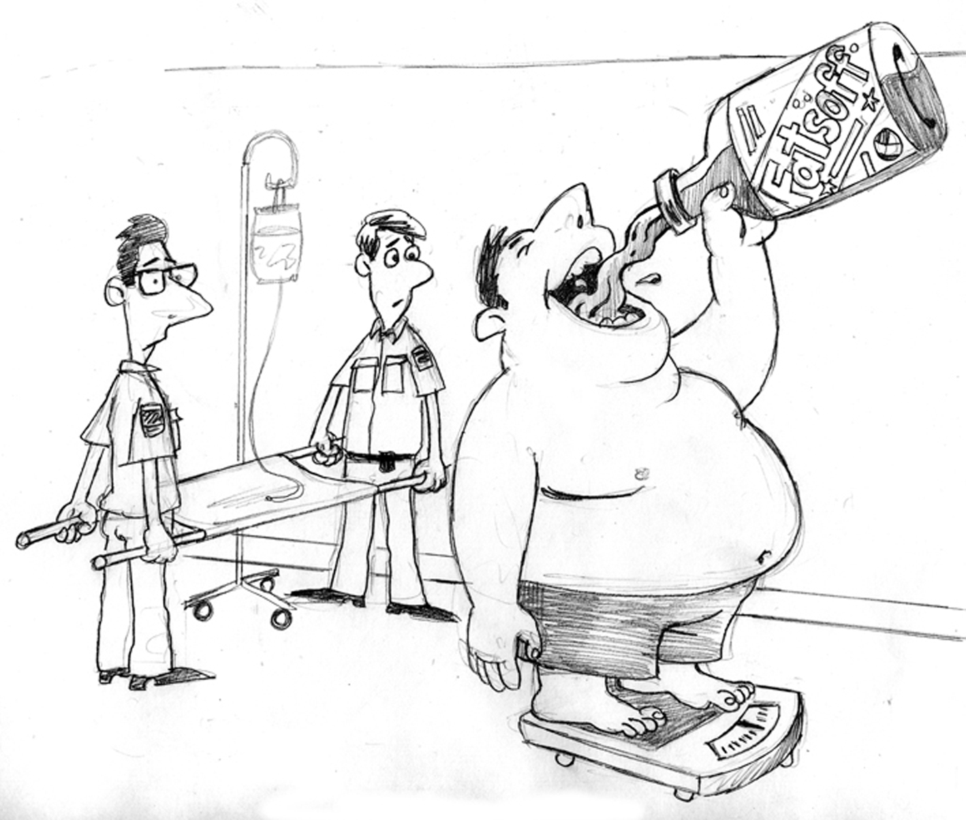
Do you think that the production and use of Fatsoff should be banned? You will need to justify your answer. Consider the issue in terms of health, social and economic impact.

